Abhinav Humar, MD

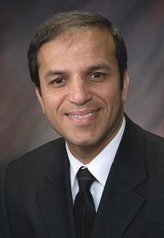
Dr. Abhinav Humar is the Clinical Director of the Thomas E. Starzl Transplantation Institute and the Chief, Division of Transplantation in the Department of Surgery at the University of Pittsburgh Medical Center. He is also a Professor in the Department of Surgery at the University of Pittsburgh School of Medicine and a Staff Physician at the Pittsburgh VA Medical Healthcare System. Prior to this he was a Professor and the Director for the Liver Transplant Program at the University of Minnesota.

Dr. Humar received his medical degree from the University of Ottawa, from which he graduated magna cum laude and was the silver medalist of his class. After completing several fellowships at the University of Ottawa and the University of Western Ontario, Dr. Humar earned a research and clinical fellowship in transplant surgery at the University of Minnesota in 1996.

Dr. Humar’s clinical interests include:

- Adult abdominal transplants (kidney, liver, pancreas, and bowel)
- Pediatric transplants
- Living-related liver transplants
- Split liver transplants
- Hepatopancreaticobiliary surgery

His research interests are:

- Partial liver transplants and studies of hepatic regeneration
- Clinical outcome studies in kidney, liver, and pancreas transplants
- Clinical outcomes both short and long term in donors and recipients of living donor liver transplants
- Clinical studies and trial to promote tolerance after transplant

